9. Roll Up Summary, Cross Formula Field, Mini Page Layout, Re-Pareting - 07 March 2022

1] Roll Up Summary

2] Cross Formula Field

3] Mini Page Layout

4] Re-Parenting

Rollup Summary Field:

It is a Read-Only field, which is used to apply Aggregate Functions (SUM, COUNT, MIN, MAX)

over details Records.



1] COUNT

|  |  |
| --- | --- |
| Applicant | Addresses (City) |
| Bunty | Nagpur |
| Pune |
| Karchi |

Bunty (TOTAL) = 03

Bunty (Pune) = 01

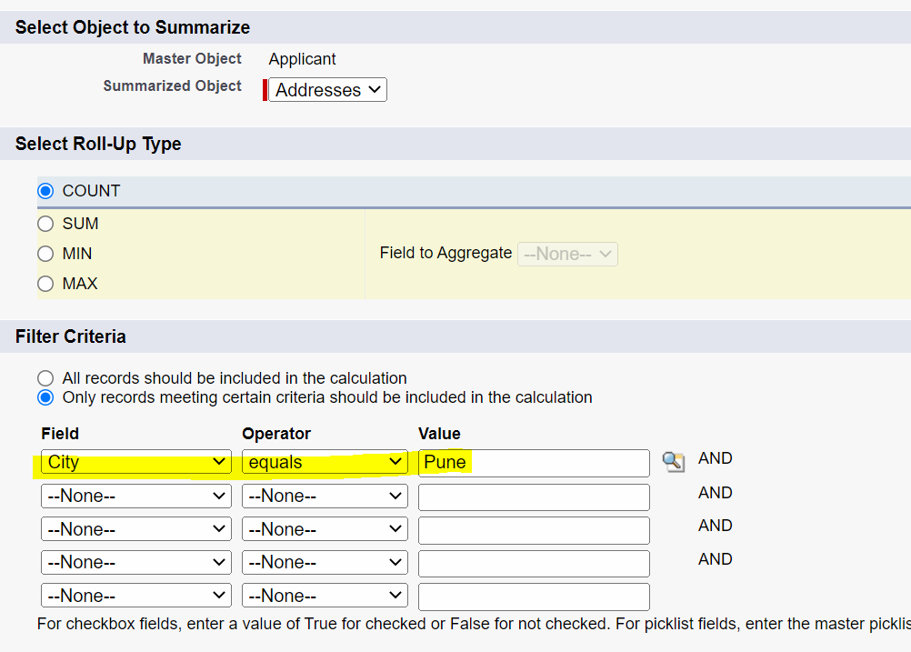

Assignment:

1] Show India OR Pakistan Address Count.

|  |  |
| --- | --- |
| Applicant | Addresses (Country) |
| Bunty | India |
| Pakistan |
| India |
| Srilanka |
| USA |

India Or Pakistan = 03

2] SUM

|  |  |  |
| --- | --- | --- |
| Applicant | Addresses (City) | Plot Cost |
| Bunty | Nagpur | 100 |
| Pune | 200 |
| Karachi | 500 |
| Pune | 1800 |

SUM (All) = 2600

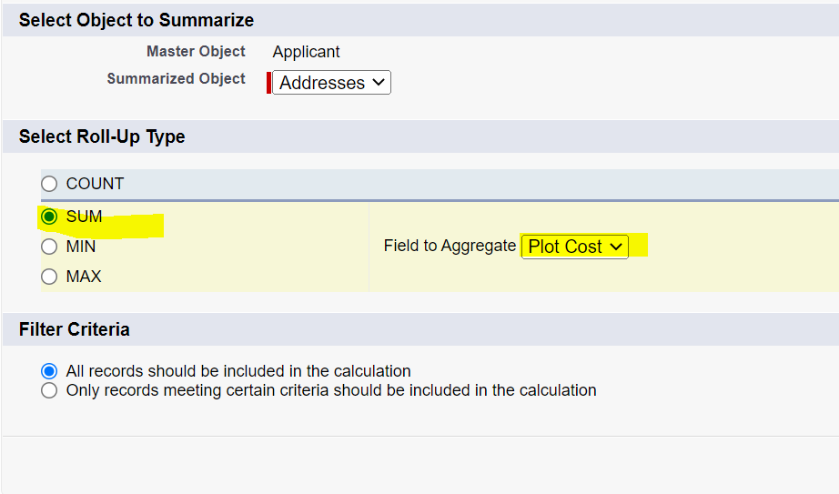

Sum (Pune) = 2000

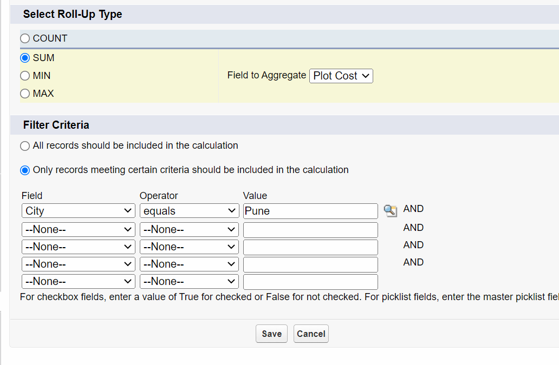

3] MIN

|  |  |  |
| --- | --- | --- |
| Applicant | Addresses (City) | Plot Cost |
| Bunty | Nagpur | 100 |
| Pune | 200 |
| Karachi | 500 |
| Pune | 1800 |

Min (All) = 100

Min (Pune) = 200

Min (Pune OR Nagpur) = 100

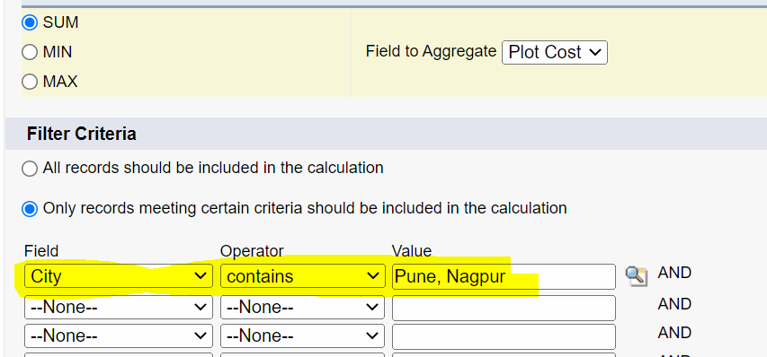

4] MAX

Max (All) = 1800

Max (Pune) = 1800

Max (Pune OR Nagpur) = 1800

MINI PAGE LAYOUT

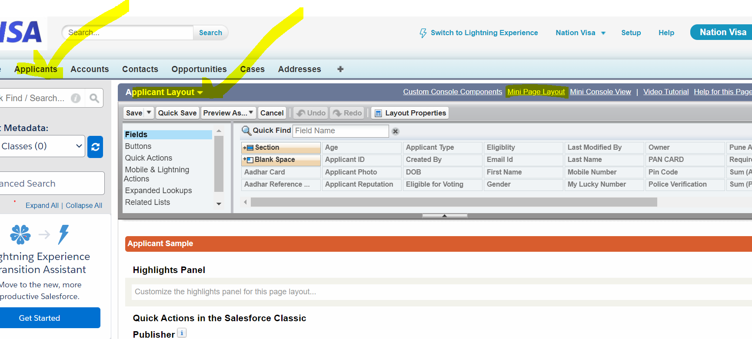

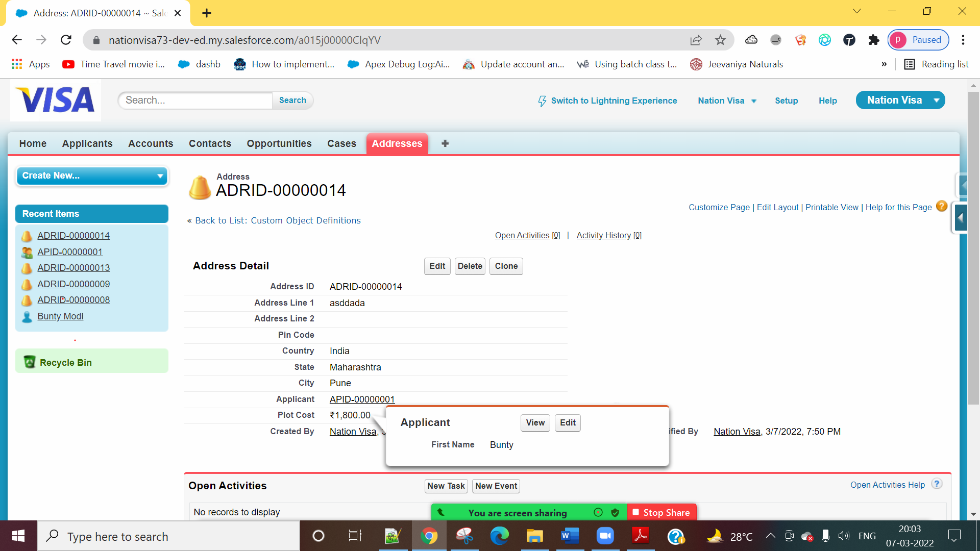



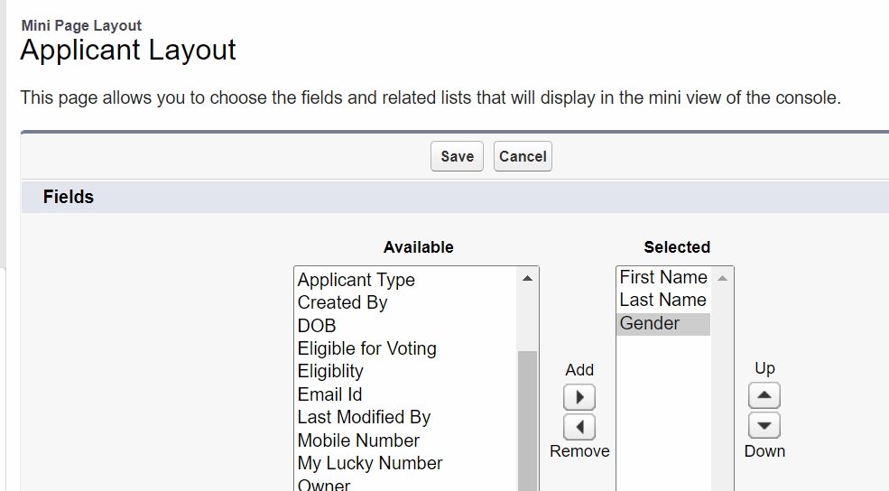

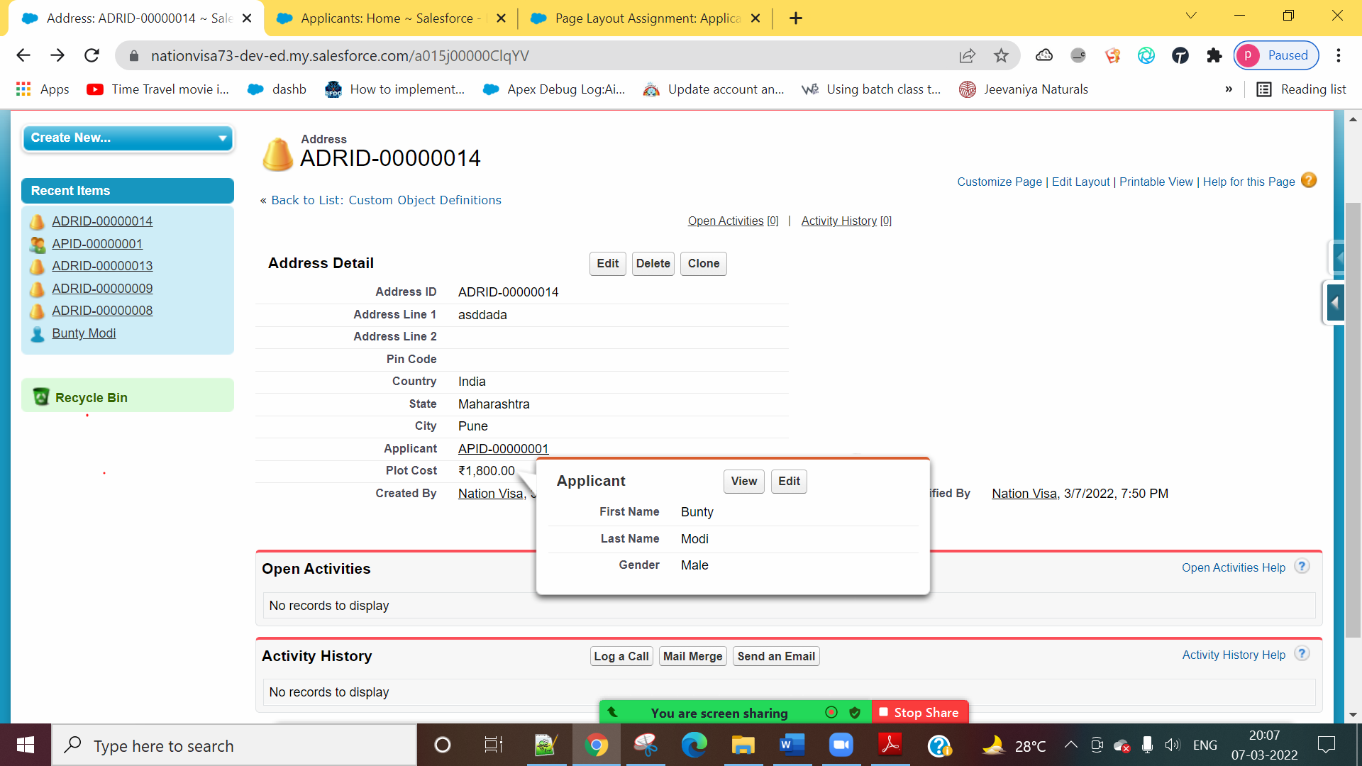



Cross Formula Field



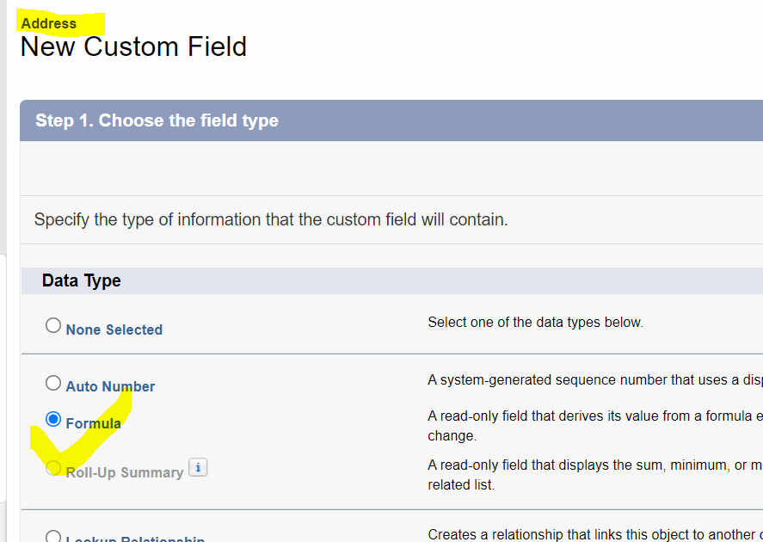

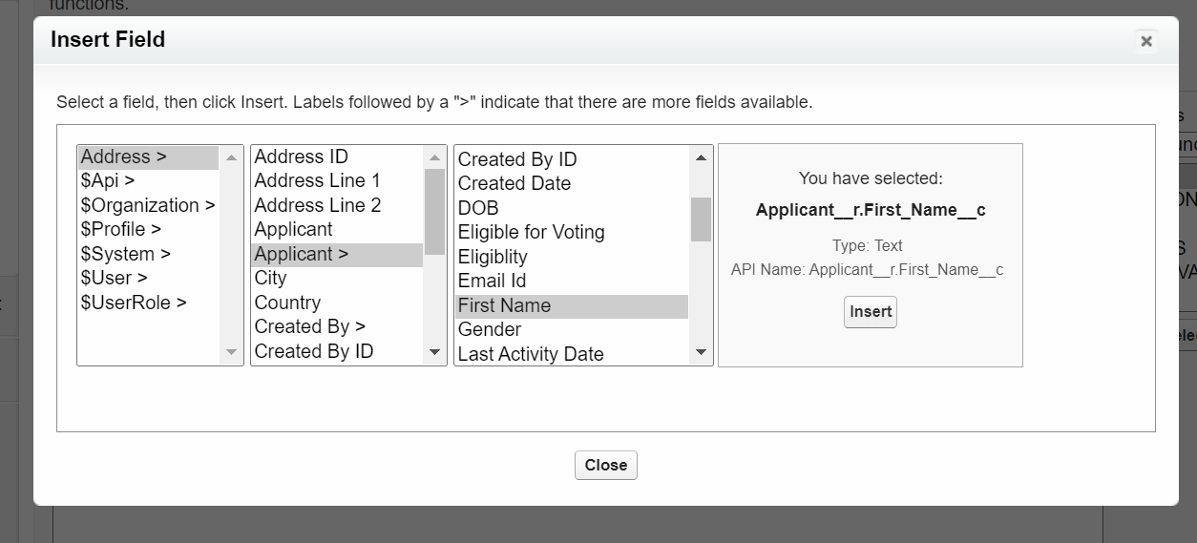

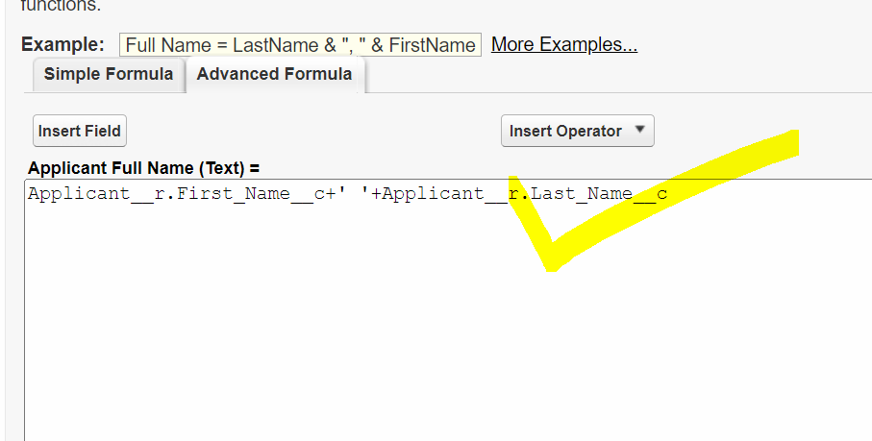

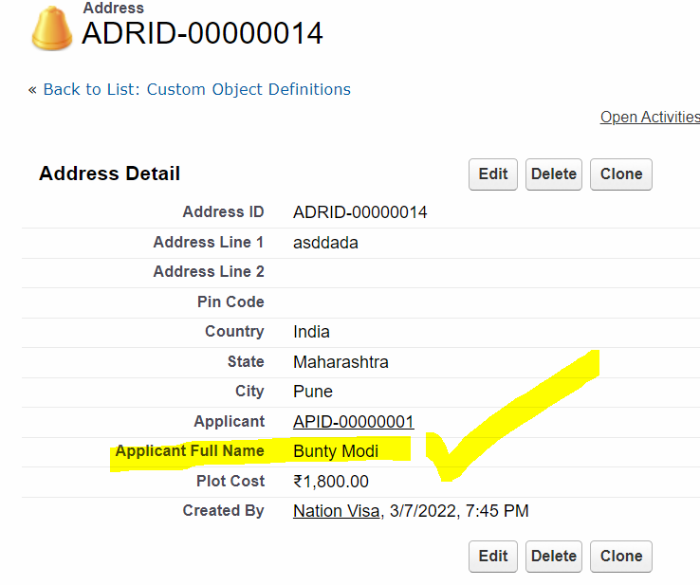

User Story 2] Show Applicant’s PAN Card on Address Side.

Condition:

Show only then, when Applicant’s Age is greater or equals to 18. Else Blank (Pan Card).

IF( Applicant__r.Age__c >=18 , Applicant__r.PAN_CARD__c , ' ')

===========================

Re – Parenting

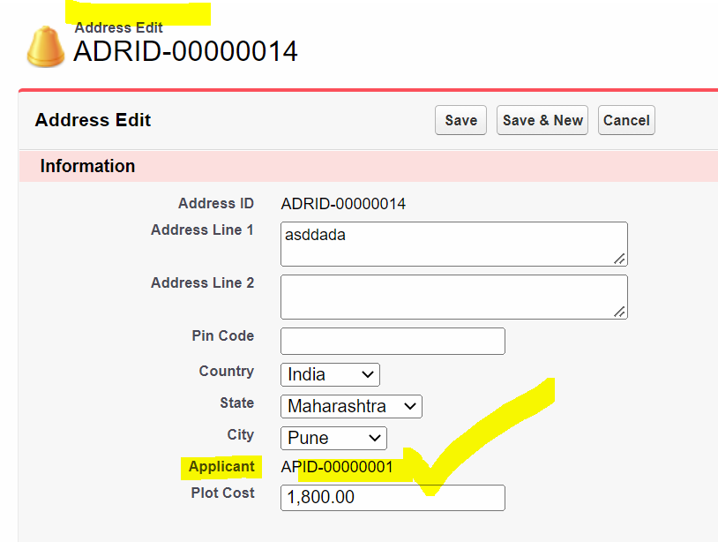

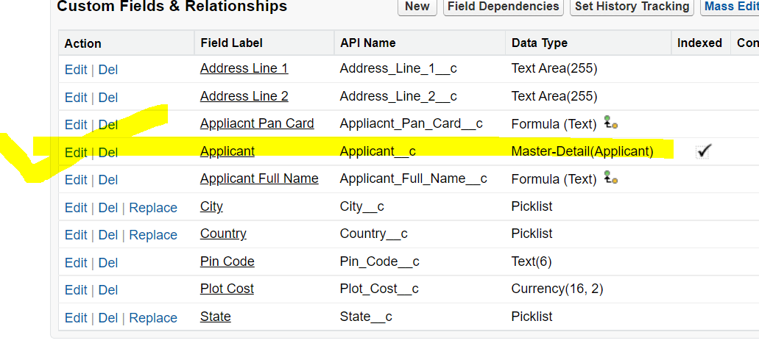

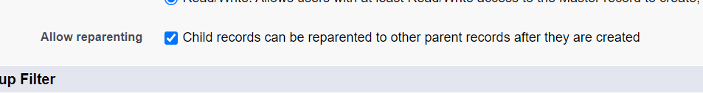

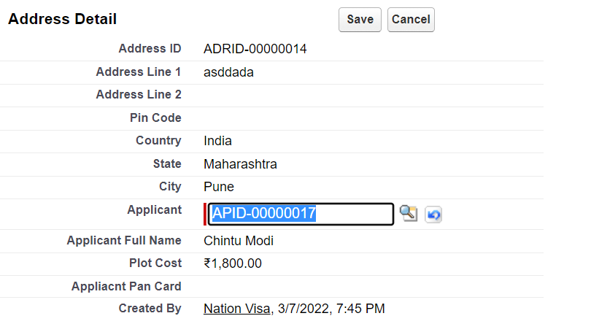

Date Setting:

MM/DD/YYYY

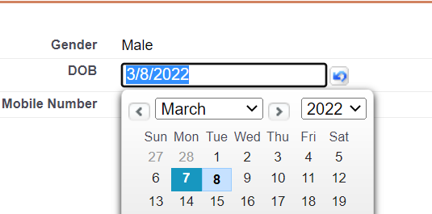

DD/MM/YYYY

